1. Bash script to print odd numbers from the list. (12,5,7,10,8,19,20,23,25)

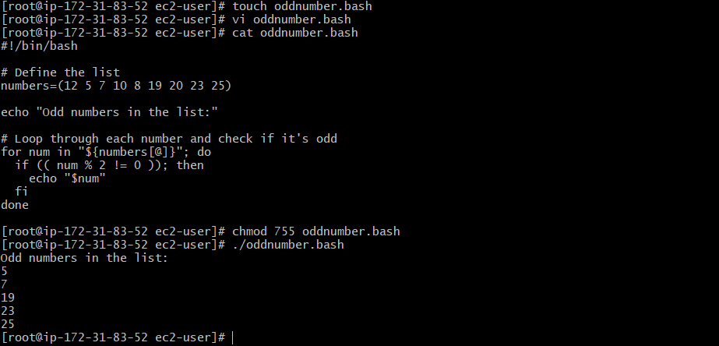

1. Bash script to take a input from user and check if it is greater than or less than 10

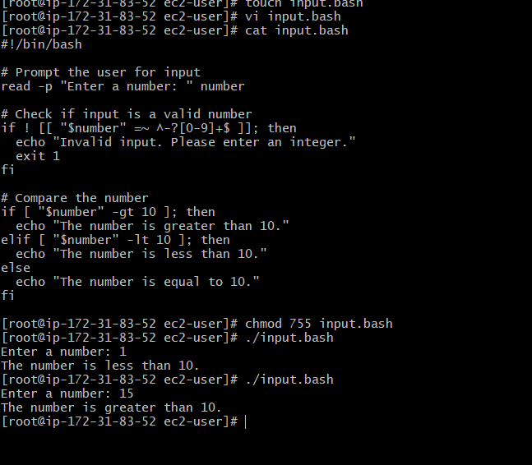

1. Bash script to login to multiple servers and check if httpd service is running or not 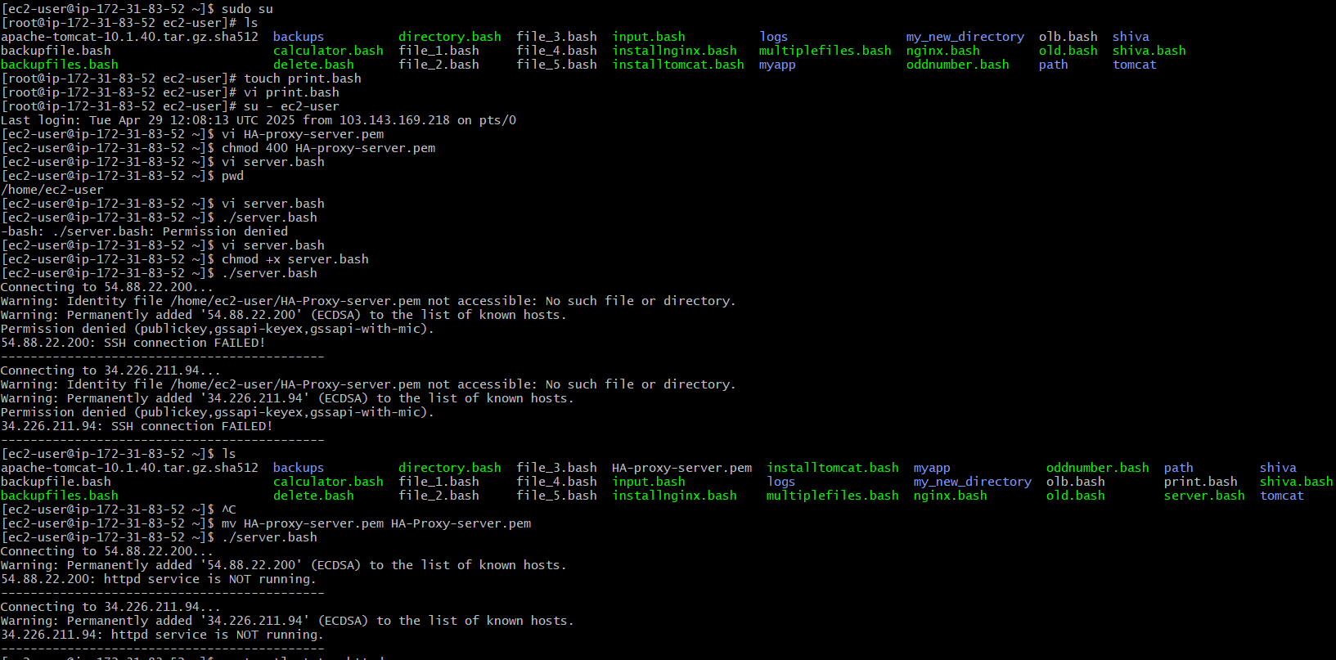

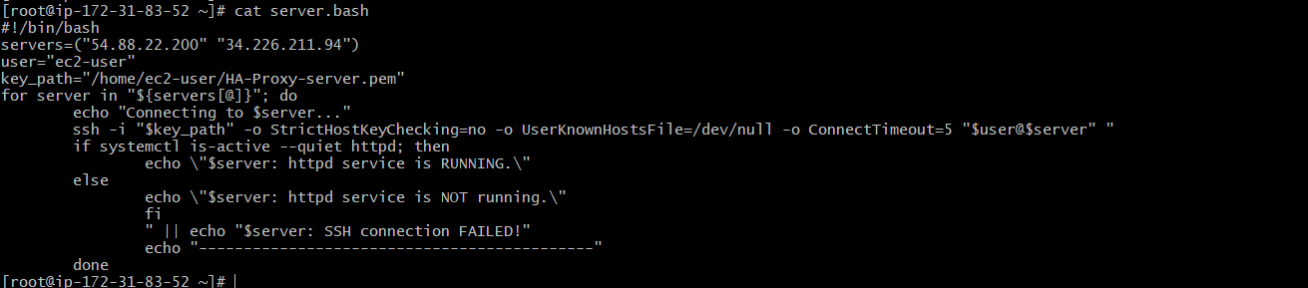

1. Bash script to check the log files from a path and delete files older than 20 days.

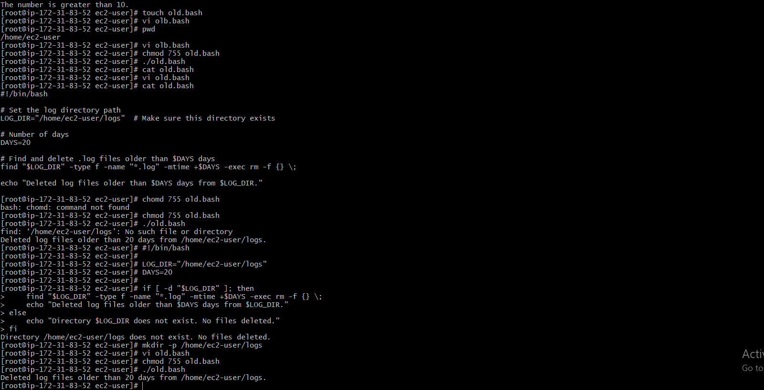

1. Bash script to print 3rd word and 5th word from the given input of user

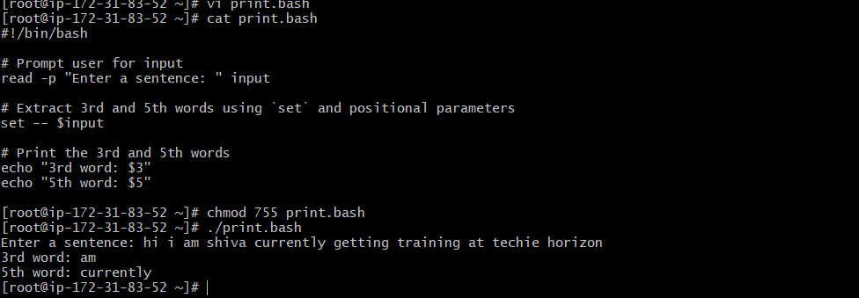

1. Bash script to print numbers between 1 to 100 and then seperate the odd numbers and even numbers

